Output of program 1:

1. Run configuration:

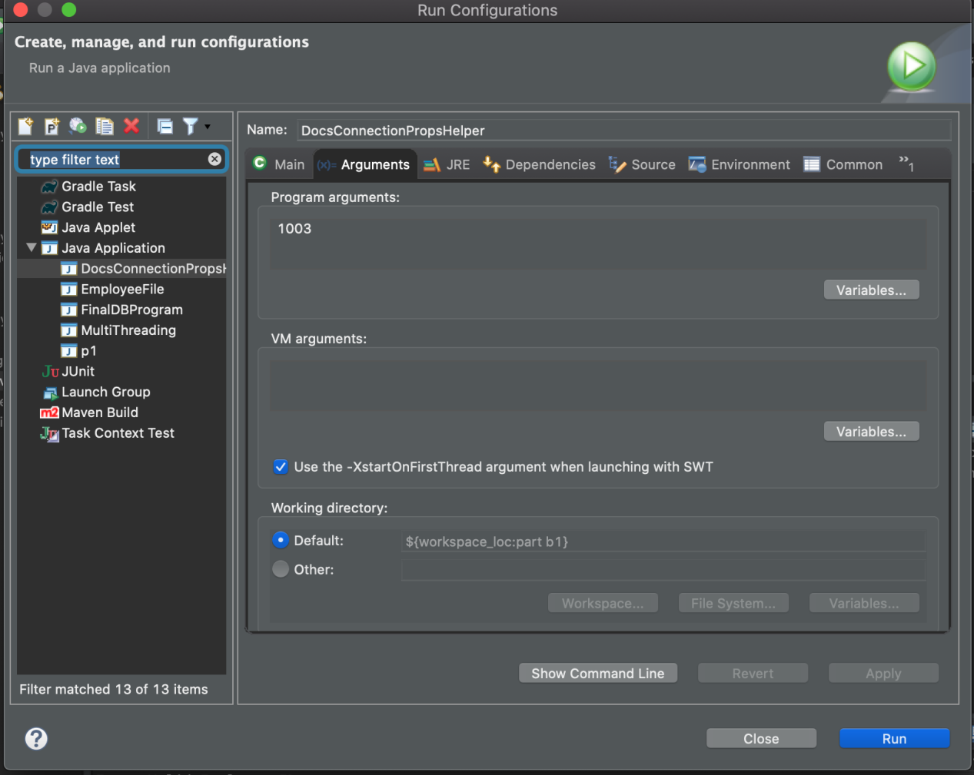

1. Output:

